Lesson 5: Debugging

|  |  |  |  |
| --- | --- | --- | --- |
| **Name:** | **................................................................................................................** | **Class:** | **.............** |

1. Your task is to fix as many errors as you can find in [this web page](https://csinschools.io/web-fundamentals/0501e/repl).

* There are at least 11 errors. How many can you find?

**Hints:**

* There are clues in the webpage information
*  indicates this line of code needs attention
* don't forget to look at both **index.html** and **style.css** to identify all the bugs.

## **style.css**

|  |  |
| --- | --- |
|  | <body> {  background-color: lightgray;  }  h1 {  color:darkcyan  text-decoration: underline;  }  #blue {  color: blue;  }  p {  background-colour: azure;  padding: 10px;  ul {  color: red;  } |

# 

## **index.html**

|  |  |
| --- | --- |
|  | <!DOCTYPE html>  <html>  <head>  <meta charset="utf-8">  <meta name="viewport" content="width=device-width">  <title>Debugging</title>  <link href="style.css" rel="stylesheet" type="text/css" />  </head>  <body>  <h1 Debugging</h1>  <img source="csinschools.png" alt="CS in Schools" />  <p>Your task is to fix as many errors as you can find in this web page.  There are at least 10 errors. How many can you find?  <h2 class="blue">Common HTML Errors</h2>  <paragraph>Some common errors in HTML include:</paragraph>  <ul>  <li>Forgetting the opening tag</li>  Forgetting the closing tag</li>  <li>Using the wrong tag name</li>  <li>Forgetting a &lt; or &gt;</li>  <li>Forgetting a / in the closing</li>  </ul>  <hr />  <h2 class="blue">Common CSS Errors<h2>  <p>Some common errors in CSS include:</p>  <ul>  <li>Including an &lt; and &gt; in the selector</li>  <li>Forgetting a semicolon after a rule</li>  <li>Spelling color as colour</li>  <li>Having an # as a selector for a class rather than a .</li>  <li>Forgetting either the opening or closing curly braces {} in a CSS rule</li>  </ul>  </body>  </html> |

## Webpage: Bug Free!

This is what the web page should look like once you have fixed up the errors:

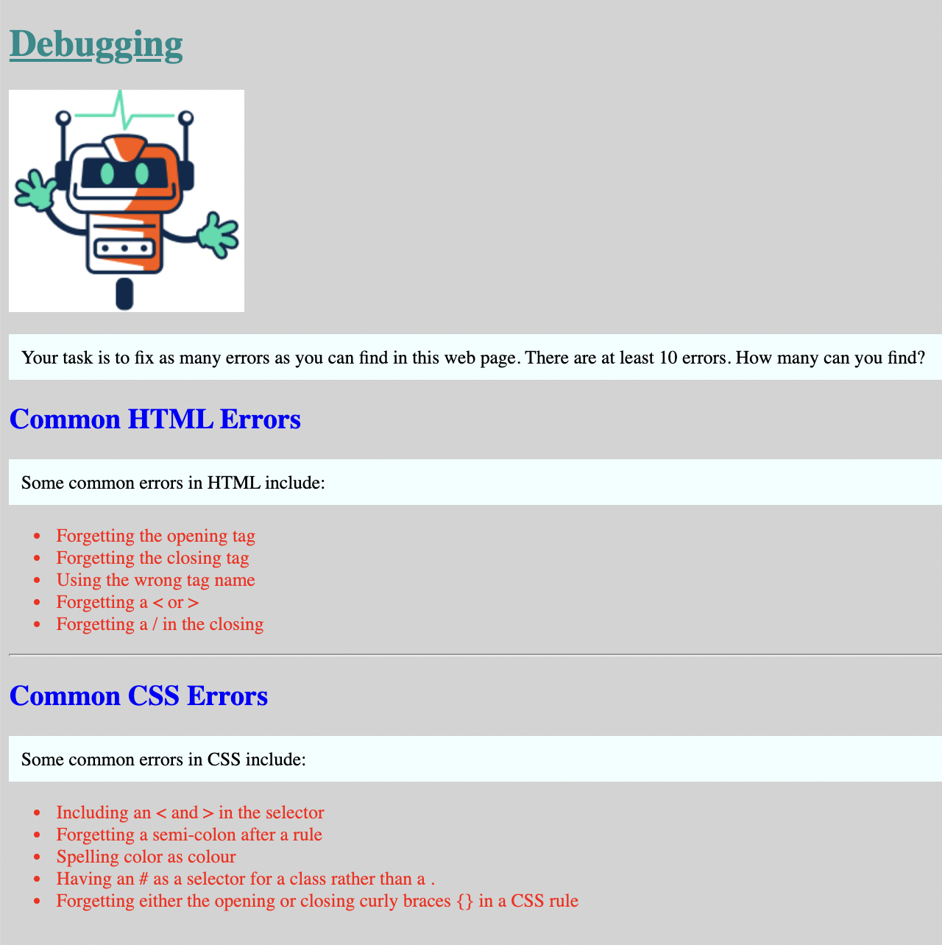

## Extension Activity: Get Creative!

Have a go at changing the:

* Colours
* Headings
* Image
* Alignment